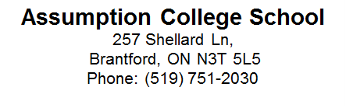

September 19, 2018

Dear Parents/Guardians
On September 24th, 2018, Assumption College School is pleased to present our grade 9 girls with an amazing opportunity. This special day will be called “Girl’s Day” and it is the first year this is being offered to our students.
The event will be held in our school, in the gym, for the entire day. There is no cost to the students and all that is asked is they bring their own lunch.
The day will be led by a facilitator that will be brought in to our school for this event. She will have a team with her and several Assumption teachers will also be present in the discussions.
The intent of this event is to strengthen the bond between females, to encourage respect, and to see the value in each other. Grade 9 is often a socially difficult year as well as an academic adjustment and Assumption College School wants to make every effort to have all grade 9 girls feel comfortable in our school.
The girls will be working in groups and completing activities in which the topics will be decided upon by their choices and interests. Topics will vary and can include, anxiety, stress, and/or bullying.
This day is sure to be an excellent day for all girls involved and we look forward to seeing all of our grade 9 girls with us in the gym on September 24th!
Please note that the girls are to be wearing their proper uniform and shoes for the day.

Please sign below to indicate that you are aware that your daughter will be out of the classroom, but in the school for the entire duration of the school day on the 24th.

I ____________________________ understand that my daughter___________________________ will be in the gym on September 24th to participate in the Girl’s day Event at Assumption College School.

____________________________ _____________________________
Parent Signature Date

