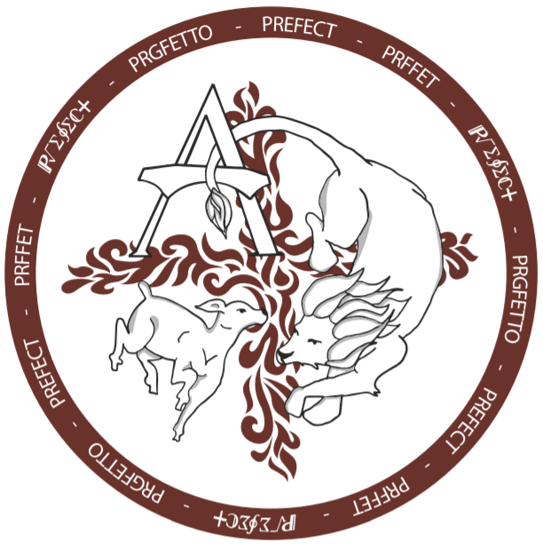

ACS Prefect 2019: SEM1
Exam Preparation and Study Blitz– Scrolling Announcements
_____________________________________________________________________________________

ACS is blessed to be offering FREE Final Exam Preparations from Mon. January 14 to Thurs. January 17 between 3-4pm in the school’s library (Think Tank). Several ACS Prefects and staff are offering free tutoring and exam preparations, including study tips and strategies, for all students. Computers and printers are available. This is a great opportunity for students who may have incomplete course culminating activities and/or summative assignments to complete them. Please encourage your son or daughter to attend. Best of luck on final exams Lions and God bless.

Office Notes:
To scroll from: Wed. Jan 9-Thurs. Jan 17

